EXECUTIVE GAME THEORY CURRICULUM • 12-WEEK MASTER ARCHITECTURE
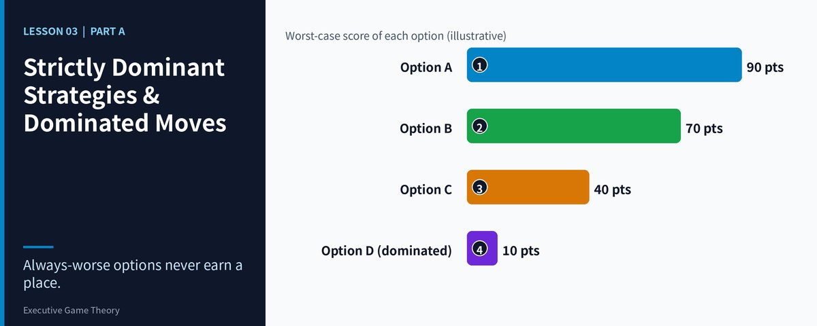

Lesson 03: Strictly Dominant Strategies & Dominated Moves
Analytical Blueprint — The Dominance Test: Finding the Move That Always Wins and the Move That Always Loses
Strategic Focus & Learning Objective: In this topic, we will be learning how to apply the Strict Dominance Test and Iterated Elimination of Strictly Dominated Strategies (IESDS) to solve the Single-Best-Move Fallacy (hunting for one brilliant move while ignoring the options that no rational player would ever choose).
The Real-World Operational Problem: Management teams spend weeks debating which of eight strategic options is "best", then discover the debate was wasted: three of the eight were worse than another option in every possible market scenario. Time, board attention and capital are consumed defending moves that a ten-minute dominance test would have deleted. Meanwhile a rival that prunes quickly commits earlier and sets the terms of the contest.
How This Topic Solves It: The dominance test replaces opinion with a mechanical comparison: fix one rival move, compare your options, repeat for every rival move. Any option that is worse in every column is strictly dominated and can be deleted without losing anything. A smaller grid is easier to read, easier to defend to a board, and frequently exposes the equilibrium outright. This lesson gives you the test, its limits, and a repeatable boardroom protocol.
■ EXECUTIVE LEARNING ADVISORY
Do not start by asking "what is our best move?" Start by asking "which of our moves would we never defend, whatever the rival does?" Delete those first. A strategy that loses in every scenario is not a risk to be managed; it is a cost you can remove today.

Part I: The 4-Part Prelude Protocol
1. Models in Focus: Strict Dominance, Strictly Dominated Strategies, Dominant-Strategy Equilibrium, and the Iterated Elimination of Strictly Dominated Strategies (IESDS).
2. Lifelike Dilemma & Problem Statement: A regional contractor is preparing a bid for a hospital-wing fit-out against one national rival. Its bid committee shortlists three proposals: A, a premium-quality bid at a high price; B, a mid-price bid with a bundled maintenance contract; and C, a low-price bid with minimal specification. The committee spends five weeks arguing about price curves. A junior analyst finally ranks the outcomes of all three options against the rival's three possible moves (aggressive bid, moderate bid, no bid) and shows that Option C ranks below Option A in every column. No scenario exists in which the bare-bones bid is the best choice, yet it had absorbed half of the debate.
3. Component Dissection: The committee committed the Single-Best-Move Fallacy. It searched for the winner instead of deleting the losers. The analyst did not need to forecast the rival at all: a strictly dominated option is worse whatever the rival does, so the rival's identity and intentions are irrelevant to the decision to drop it.
4. Lesson Embarkation: This lesson formalizes the dominance test and shows how to run it on a payoff matrix in under ten minutes, then how to repeat it (IESDS) until the game shrinks to its logical core.

Part II: The 7-Stage Core Pedagogy

Stage 1: Why Learn This (The 45-Second Operational Hook)
Every strategy meeting contains an unstated assumption: that all options on the slide deserve equal discussion time. They do not. In any matrix, some options are beaten in every column by some other option, and discussing them is pure waste. The 45-second hook is this: before you debate any option, ask whether another option on the page does at least as well in every scenario and strictly better in every scenario. If yes, the option is dominated and the debate is over.
▼ CHECKPOINT: WHAT YOU MUST KNOW BEFORE MOVING FORWARD
Never ask "which option is best?" first. Ask "which option is worse than another option in every scenario?" and delete it. You cannot lose by removing a strictly dominated move.

Stage 2: The 5-Minute Core Framework (The Dominance Test Architecture)
Your payoff ranks (4 = best, 1 = worst) for three bid options against the rival's three possible moves form a 3 × 3 grid. Run the test column by column: hold the rival's move fixed, rank your three options, then repeat.
Your bid \ Rival move | Rival: Aggressive bid | Rival: Moderate bid | Rival: No bid
Option A: Premium-quality bid | 4 (wins at a healthy margin) | 3 (wins narrowly) | 3 (wins, margin intact)
Option B: Mid-price with maintenance bundle | 3 (competitive, thin margin) | 4 (best fit for client) | 2 (wins, margin left on table)
Option C: Bare-bones low-price bid | 2 (loses on quality scoring) | 1 (loses, reputation damage) | 1 (wins but with loss-making scope)

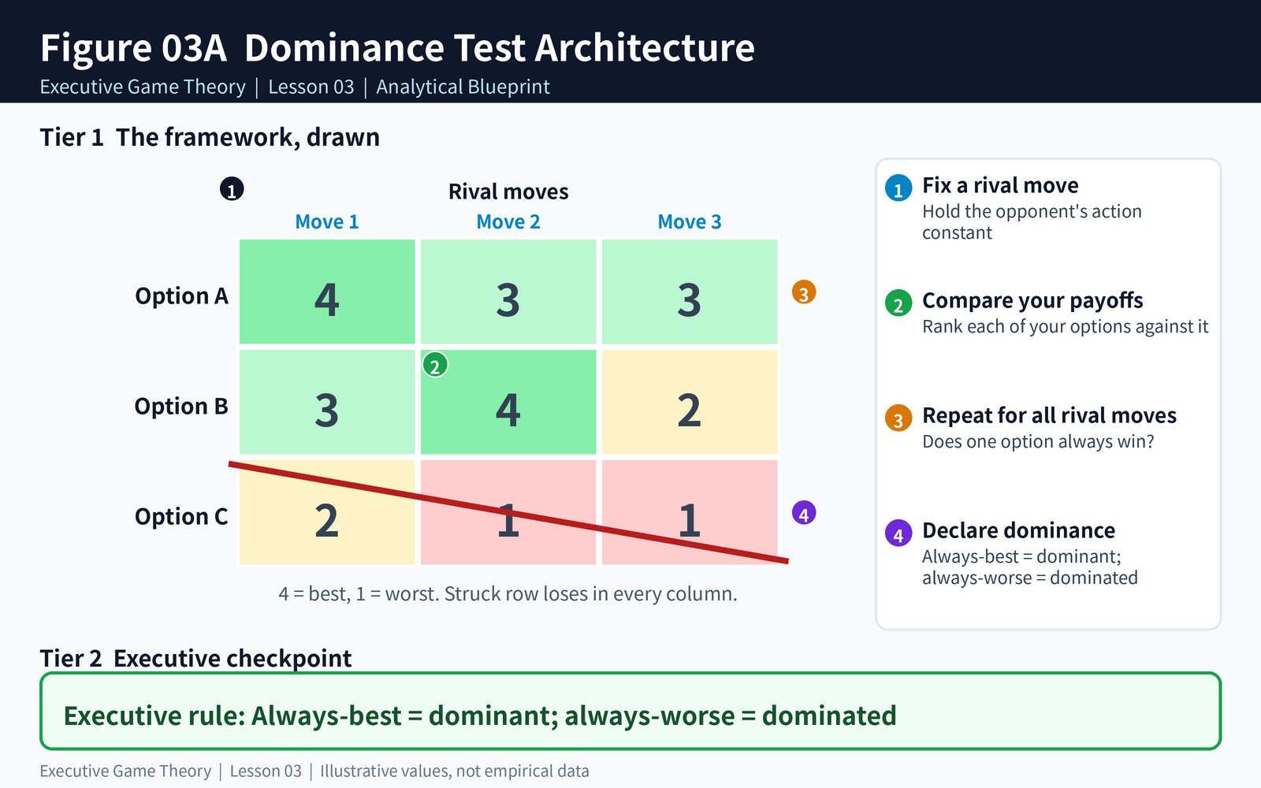
Figure 3A: Dominance Test Architecture
Figure 3A: The Dominance Test Architecture (fix a rival move, compare your payoffs, repeat for all rival moves, declare dominance)
Reading the grid: Option C scores 2, 1, 1 while Option A scores 4, 3, 3. A beats C in all three columns, so C is strictly dominated and is deleted. Notice that no option dominates all the others: Option B beats A against a moderate bid, and A beats B against the other two. Dominated moves can exist even when no dominant move does.
▼ CHECKPOINT: WHAT YOU MUST KNOW BEFORE MOVING FORWARD
A strategy is strictly dominated only if another strategy beats it in every column, not on average and not in most columns. One column that breaks the pattern means the test fails.

Stage 3: The 3-Layered Operational Deep Dive
• Layer 1 — The Mechanical Protocol (The Column Scan): Fix one rival move and rank your options against it. Repeat for every rival move. If one option is strictly better than another in every column, the weaker option is strictly dominated. If one option beats every alternative in every column, it is a strictly dominant strategy and the decision is made.
• Layer 2 — The Cognitive Failure Mode (The Averaging Trap): Executives often compare options by their average payoff across scenarios. An option can have a higher average and still be a bad choice if a single scenario is catastrophic, and an option with a lower average can be strictly dominated in none of the columns. Dominance is a column-by-column test, not an average-weighted forecast.
• Layer 3 — Boundary Conditions: Dominance needs strictness. If two options tie in even one column the dominance is only weak, and deleting weakly dominated options can remove genuine equilibria and makes the result depend on the order of deletion. Iterated deletion also requires that each player believes the others will not play dominated moves, which fails against irrational, bluffing or mis-informed rivals.
▼ CHECKPOINT: WHAT YOU MUST KNOW BEFORE MOVING FORWARD
Test column by column and demand strictness. Averages, weighted forecasts and "most scenarios" arguments are not dominance. Treat weak dominance as a hint, never as a license to delete.

Stage 4: Real-World Applications × 3
1. Commercial Tendering (Bid Shortlisting): A construction group compares five bid configurations against three rival behaviors. Two configurations lose to others in every column and are removed in the first meeting, cutting the tender review from three weeks to four days.
2. Airline Fare Filing (Booking-Class Strategy): A carrier ranks six fare-class rules against rival price moves. Four rules are dominated by a simpler fare ladder; the revenue team stops modelling them and redirects analyst time to the two live options.
3. Software Licensing (Pricing Plan Pruning): A SaaS vendor reviews seven licensing structures against three competitor reactions. After the dominance test only three structures survive, and the pricing committee can present a one-page decision to the board.
▼ CHECKPOINT: WHAT YOU MUST KNOW BEFORE MOVING FORWARD
In every commercial decision, list the options and the rival scenarios first, then delete everything strictly dominated before any financial modelling. Modelling a dominated option is analyst time you cannot recover.

Stage 5: Diagnostic Self-Quiz & Evaluative Rubric
Scenario: Your logistics company can choose Plan X, Plan Y or Plan Z against three possible rival moves. Your ranks (4 best, 1 worst) are X: 4, 2, 3; Y: 3, 2, 2; Z: 1, 1, 1. Which statement is correct?
A) Z is strictly dominated by both X and Y. B) Y is strictly dominated by X. C) X is a strictly dominant strategy. D) No option is dominated because the averages are close.
Recommended Answer —A: Y scores 3, 2, 2 against X's 4, 2, 3, so X is better in columns one and three but only equal in column two. That is weak dominance, not strict dominance, so B is wrong. Z (1, 1, 1) loses to both X and Y in every column, so A is correct. Always check strict inequality in every column before deleting an option.
▼ CHECKPOINT: WHAT YOU MUST KNOW BEFORE MOVING FORWARD
Equal payoffs in a single column turn strict dominance into weak dominance. Always verify strictness in every column before you delete anything.

Stage 6: What You Should Know by Now (Daily Life Translation)
■ THE DAILY LIFE TRANSLATION
Choosing a commute is a dominance test. If Route 1 is the same price as Route 2 but takes longer in rush hour, in light traffic and in rain, Route 2 strictly dominates it and you never need to discuss Route 1 again. If Route 1 is faster only when it does not rain, you have no dominance and you need a forecast. The test tells you instantly whether you need a forecast at all.

▼ CHECKPOINT: WHAT YOU MUST KNOW BEFORE MOVING FORWARD
Sometimes the best decision-making shortcut is realizing that no decision is required. Delete dominated options and spend your forecasting effort only where it can change the answer.

Stage 7: Self-Regulated Practice & Interactive Discovery
Take a live decision on your desk with at least three options and at least three outside scenarios. Rank every option in every scenario from 4 to 1, then run the column scan. Write down which options are strictly dominated, which are only weakly dominated, and whether any option dominates all the rest. Then test the result in the two companion games below.
▼ CHECKPOINT: WHAT YOU MUST KNOW BEFORE MOVING FORWARD
Five minutes of column scanning before a strategy meeting often removes half of the options. Do it before the meeting, not during it.

Topic 03 Companion Games: Operational Briefing & Deployment
1. Pedagogical Intent: Convert this lesson into instinctive boardroom reflexes through twin interactive engines hosted on GitHub Pages.
2. Executive Objectives:
• Game 1 (Cull the Dominated, Video Game): Spot the strictly dominated move before the clock runs out
• Game 2 (Tender Elimination Chain, Business Simulation): Iterated elimination in a contract-bidding standoff
3. Scoring Standards: Passing the calibration quiz in Game 1 activates a 200% Entry Buff. Game 2 carries DOUBLE WEIGHT (2x) on the unified leaderboard. Every session is time-limited, and finishing a game unlocks the Get Certified button for a 1-5 golden star victory certificate.
4. Playable Online Links:
• Game 1 (Cull the Dominated): https://firedancerx.github.io/Game-Theory/Games/Lesson%2003/game1_cull_the_dominated.html
• Game 2 (Tender Elimination Chain): https://firedancerx.github.io/Game-Theory/Games/Lesson%2003/game2_tender_elimination_chain.html
• Master Platform Portal: https://firedancerx.github.io/Game-Theory/

Appendix: Obsidian Knowledge Graph Semantic Triplets
Import these atomic triplets into your executive knowledge vault (Obsidian / Logseq):
%%
[[Strict Dominance]] --[means]--> [[Better In Every Scenario]]
[[Dominated Strategy]] --[is]--> [[Safely Deletable]]
[[Dominant Strategy]] --[ends]--> [[Strategic Deliberation]]
[[IESDS]] --[repeats]--> [[Dominance Test]]
[[Weak Dominance]] --[risks]--> [[Deleting Equilibria]]
[[Averaging Trap]] --[confuses]--> [[Mean Payoff With Dominance]]
[[Common Knowledge Of Rationality]] --[underpins]--> [[Iterated Deletion]]
%%
Concept Entity | Historical Origin & Date | Obsidian Semantic Triplets | Executive Commercial Meaning
[[Strict Dominance]] | John von Neumann & Oskar Morgenstern, Theory of Games and Economic Behavior (1944) | [[Strict Dominance]] --[means]--> [[Better In Every Scenario]] | An option that beats another in every scenario makes the weaker option safe to delete.
[[IESDS]] | Hervé Moulin, dominance-solvable games (1979); David Pearce and Douglas Bernheim, rationalizability (1984) | [[IESDS]] --[repeats]--> [[Dominance Test]] | Delete dominated moves, then re-test the smaller grid until nothing more can be removed.
[[Common Knowledge Of Rationality]] | Robert Aumann, Agreeing to Disagree (1976) | [[Common Knowledge Of Rationality]] --[underpins]--> [[Iterated Deletion]] | Iterated deletion is only as reliable as your belief that rivals will not play dominated moves.

